** EXPERIMENT NUMBER 1.3 Zener diode**

**Student Name: Shinde Smita Shahaji UID: 20BCS4643**

**Branch: CSE (IOT) Section/Group: IOT (Group-B)**

**Semester: 2nd semester Date of Performance:04/03/2021**

**Subject Name: Quantum and Semiconductor physics lab**

**AIM OF THE EXPERIMENT –**

To draw the reverse characteristics of Zener diode.

**APPARATUS –**

|  |  |  |  |
| --- | --- | --- | --- |
| **Sr.no** | **Equipment** | **Range** | **Quantity** |
| 1. | Regulated Power supply | 0-30V | 1 |
| 2. | Zener diode | 5V/7V/10V | 3 |
| 3. | Voltmeter | 0-30V | 2 |
| 4. | Ammeter | 100mA | 1 |
| 5. | Connecting wires | NA | 13 |
| 6. | Resistance | 1Kohm | 2 |
| 7. | Rheostat | 1Kohm | 1 |

OBSERVATIONS-

* Diode selected- ZD5234A
* Load resistance- 2000 ohm
* Series resistance- 500 ohm

|  |  |  |
| --- | --- | --- |
| **Sr.no** | **Reverse voltage across the diode (volts)** | **Reverse current thorught the diode I(mA)** |
| 1. | 0.120 | 0.000 |
| 2. | 2.206 | 0.000 |
| 3. | 3.058 | 0.001 |
| 4. | 4.094 | 0.002 |
| 5. | 5.013 | 0.003 |
| 6. | 6.200 | 0.011 |
| 7. | 6.200 | 0.013 |
| 8. | 6.200 | 0.015 |
| 9. | 6.200 | 0.017 |
| 10. | 6.200 | 0.019 |
| 11. | 6.200 | 0.021 |

CIRCUIT DIAGRAM-

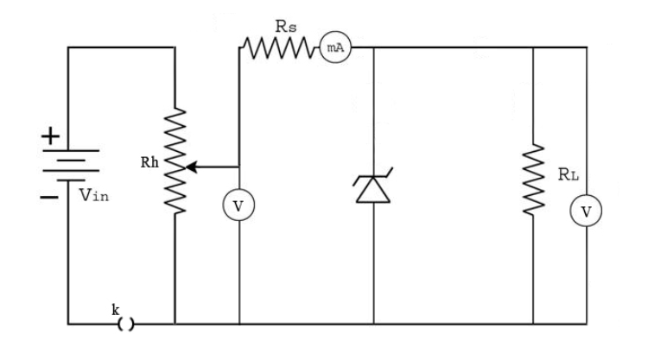

SIMULATION:

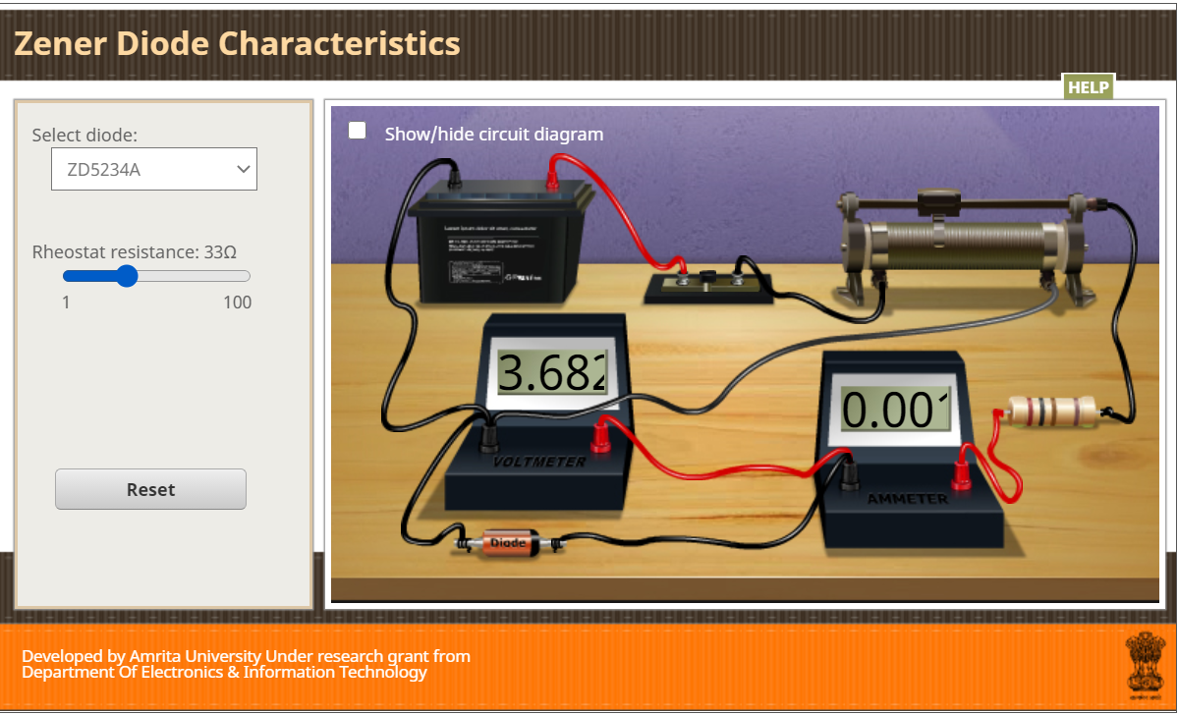

CALCULATIONS- No calculation part in this experiment

PERCENTAGE ERROR- No percentage errors

GRAPH (ATTACH IF ANY)- 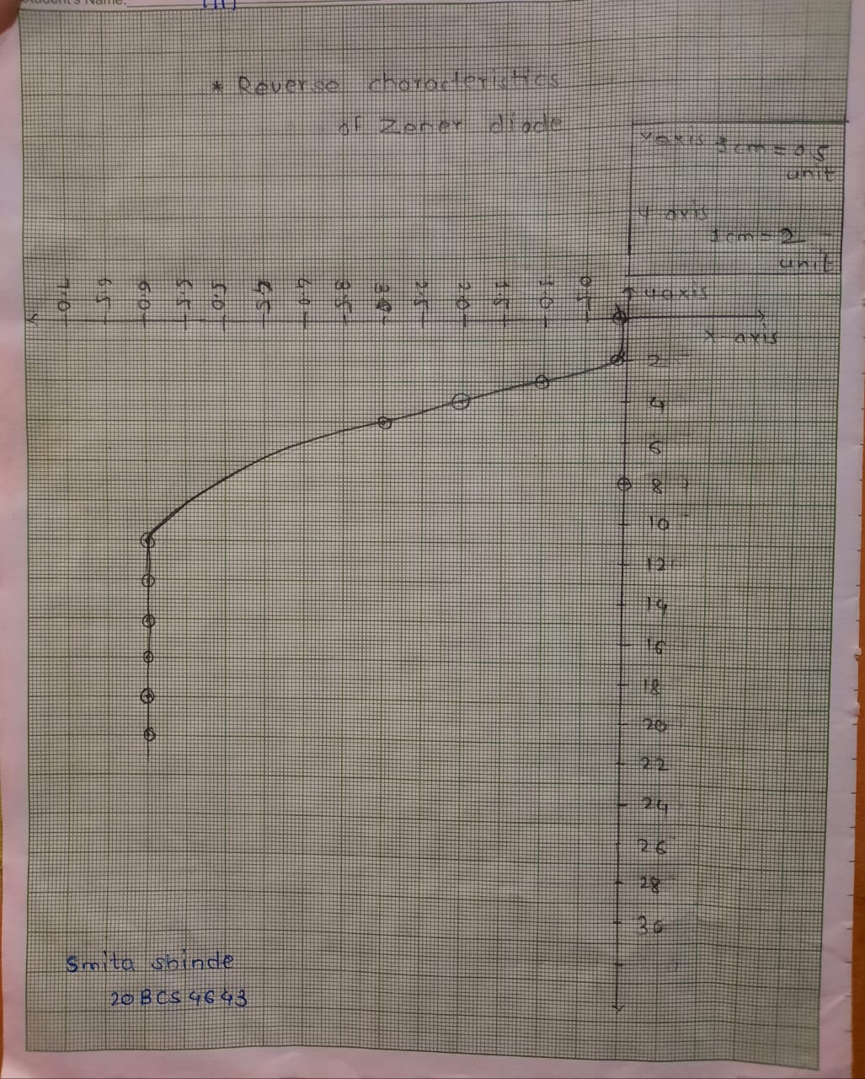

SOURCES OF ERROR-

* Excessive flow of current may damage the diode.
* Current for sufficiently long time may change the characteristics.
* Connections should be made neat and clean.

RESULTS AND DISCUSSION-

* The value of breakdown voltage from graph is 6.200

DISCUSSION-

* A Zener diode is heavily doped p-n junction diode, specially made to operate in the break down region. A p-n junction diode normally does not conduct when reverse biased. But if the reverse bias is increased, at a particular voltage it starts conducting heavily. This voltage is called Break down Voltage. High current through the diode can permanently damage the device. To avoid high current, we connect a resistor in series with Zener diode. Once the diode starts conducting it maintains almost constant voltage across the terminals whatever may be the current through it, i.e., it has very low dynamic resistance. It is used in voltage regulator

Conclusion:

* The Zener diode, with its accurate and specific reverse breakdown voltage, allows for a simple, inexpensive voltage regulator. Combined with the right resistor, fine control over both the voltage and the supply current can be attained. However, the low power ratings of standard Zener diodes and resistors make this solution impractical for high power devices

LEARNING OUTCOMES

|  |
| --- |
| * It will provide the modest experience that allows students to develop and improve their experimental skills and develop ability to analyze data. |
| * Ability to demonstrate the practical skill on measurements and instrumentation techniques of some Physics experiments. Students will develop the ability to use appropriate physical concepts to obtain quantitative solutions to problems in physics. |
| * Students will demonstrate basic experimental skills by setting up laboratory equipment safely and efficiently, plan and carry out experimental procedures, and report verbally and in written language the results of the experiment. |
| * Students will develop skills by the practice of setting up and conducting an experiment with due regards to minimizing   measurement error. |

EVALUATION COLUMN (To be filled by concerned faculty only)

|  |  |  |  |
| --- | --- | --- | --- |
| **Sr. No.** | **Parameters** | **Maximum Marks** | **Marks Obtained** |
| 1. | Worksheet completion including writing learning objectives/Outcomes. (To be submitted at the end of the day) | 10 |  |
| 2. | Post Lab Quiz Result. | 5 |  |
| 3. | Student Engagement in Simulation/Demonstration/Performance and Controls/Pre-Lab Questions. | 5 |  |
| 4. | Total Marks | 20 |  |
| 5. | Teacher’s Signature (with date) |  | |